System Calls and Process Creation
Operating System Lab (5 Marks)
Name: Pankaj Kumar | Roll No: 2401010211 | Section: D Environment: WSL (Linux) | Language: Python 3
Task-wise Summary
# | Task | System call / Command used
1 | Create child process | os.fork()
2 | Display PID and PPID | os.getpid(), os.getppid()
3 | Wait for child | os.waitpid(pid, 0)
4 | Run harmless Linux command | os.execvp('ls', ['ls','-l'])
5 | Create/write/read/close file | os.open(), os.write(), os.read(), os.close()
6 | Inspect device / proc interface | /dev/null, /dev/zero, /proc/self/status
7 | Handle invalid path / failed op | try/except FileNotFoundError, OSError
8 | Show evidence | Summary output + screenshots below
Observations
- The parent (PID 538) created a child (PID 539); the child's PPID matched the parent's PID.
- The parent waited and received child exit status 0, so the command ran successfully.
- The child's image was replaced by ls -l using exec.
- File was created, written (31 bytes), read back and closed using low-level system calls.
- /dev/null discarded written data; /dev/zero returned null bytes; /proc/self/status exposed processinfo.
- An invalid path produced [Errno 2] No such file or directory, handled without crashing.
Execution Evidence
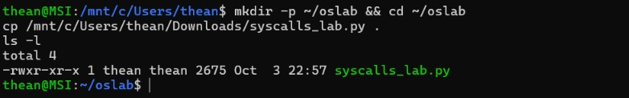
Screenshot 1: Setup - script copied into WSL working directory (~/oslab)
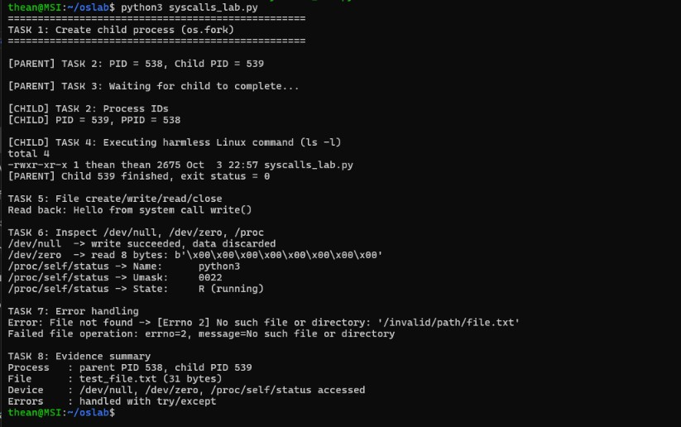
Screenshot 2: Tasks 1-8 - process creation, PID/PPID, wait, exec, file I/O, device interfaces, error handling
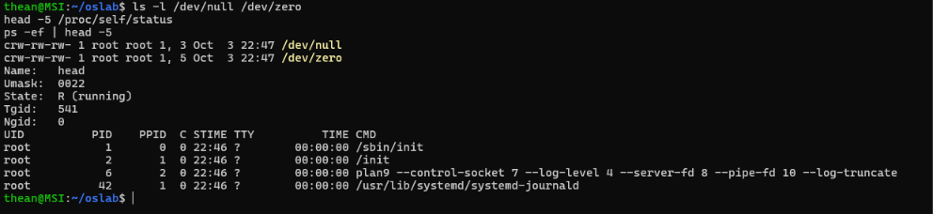
Screenshot 3: Task 6 & 8 - device files (/dev/null, /dev/zero), /proc/self/status and process list
Source Code: syscalls_lab.py
import os import sys import subprocess TEST_FILE = "test_file.txt"
print("=" * 50) print("TASK 1: Create child process (os.fork)") print("=" * 50)
pid = os.fork()
if pid == 0: # ---------- CHILD PROCESS --------- print("\n[CHILD] TASK 2: Process IDs") print(f"[CHILD] PID = {os.getpid()}, PPID = {os.getppid()}")
print("\n[CHILD] TASK 4: Executing harmless Linux command (ls -l)") sys.stdout.flush() os.execvp("ls", ["ls", "-l"]) # replaces child image # code below never runs if exec succeeds else: # ---------- PARENT PROCESS ----------
print(f"\n[PARENT] TASK 2: PID = {os.getpid()}, Child PID = {pid}")
print("\n[PARENT] TASK 3: Waiting for child to complete...") child_pid, status = os.waitpid(pid, 0) print(f"[PARENT] Child {child_pid} finished, exit status = {os.WEXITSTATUS(status)}")
# ---------- TASK 5: File operations --------- print("\nTASK 5: File create/write/read/close") fd = os.open(TEST_FILE, os.O_CREAT | os.O_WRONLY | os.O_TRUNC, 0o644) os.write(fd, b"Hello from system call write()\n") os.close(fd)
fd = os.open(TEST_FILE, os.O_RDONLY) data = os.read(fd, 100) os.close(fd) print("Read back:", data.decode().strip())
# ---------- TASK 6: Device / proc interfaces --------- print("\nTASK 6: Inspect /dev/null, /dev/zero, /proc") with open("/dev/null", "wb") as f:
f.write(b"discarded data") print("/dev/null -> write succeeded, data discarded")
with open("/dev/zero", "rb") as f:
zeros = f.read(8) print("/dev/zero -> read 8 bytes:", zeros)
with open("/proc/self/status") as f: for _ in range(3): print("/proc/self/status ->", f.readline().strip())
# ---------- TASK 7: Error handling --------- print("\nTASK 7: Error handling") try:
open("/invalid/path/file.txt", "r") except FileNotFoundError as e:
print(f"Error: File not found -> {e}") except PermissionError as e:
print(f"Error: Permission denied -> {e}") except OSError as e: print(f"Error: OS error [{e.errno}] -> {e.strerror}")
try:
os.open("/nonexistent_dir/x.txt", os.O_RDONLY) except OSError as e: print(f"Failed file operation: errno={e.errno}, message={e.strerror}")
# ---------- TASK 8: Evidence --------- print("\nTASK 8: Evidence summary") print(f"Process : parent PID {os.getpid()}, child PID {pid}") print(f"File : {TEST_FILE} ({os.path.getsize(TEST_FILE)} bytes)") print("Device : /dev/null, /dev/zero, /proc/self/status accessed") print("Errors : handled with try/except") os.remove(TEST_FILE)

